PST Revesion 9 mods:

1. R6 and R3 change to 100k
2. Remove R30
3. Cut the following trace

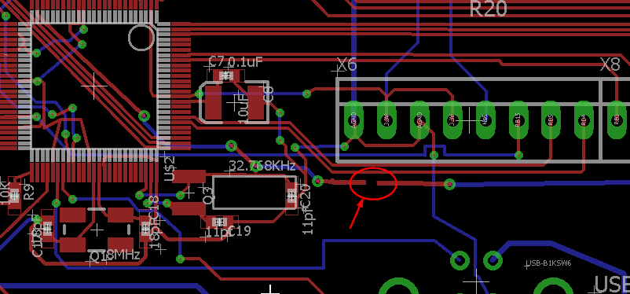

1. Make the following jumper that is in yellow.

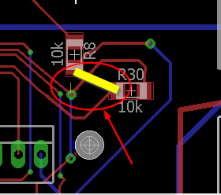

1. Cut the following traces

